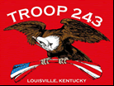
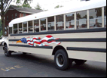
TROOP 243
March 1st, 2016
Boy Scouts of America
Chartered by St. John Paul II Catholic Church

3044 Hikes Lane Louisville, Ky 40220
3521 Goldsmith Lane http://www.troop243.com

Troop 243 Outings & Activities – We start out the month attending the Cherokee District awards dinner. Several of our leaders will receive awards of appreciation and 3 of our scouts who made Eagle in 2015 will be recognized. We’ll have a Family Life merit badge class and our Philmont Crew will continue to prepare with a significant hike. We will make a return to the Hike, Bike, Shoot and Climb Cherokee District sponsored camp out which will include all four of those activities. Leadership training and meetings will wrap up the month.

Troop and Patrol Meetings on Wednesdays - All are welcome. Scouts in Field/Class A uniforms are expected for all troop meetings while class B uniforms are ok for patrol meetings. Except where noted, all meetings are held at St. St. John Paul II’s Hikes Lane Campus. SERVICE PATROLS should arrive 15 minutes early to set up for the meeting.

March 2nd, 7:00 PM – Troop Meeting @ Engineering – The service patrol is Legacy
March 9th, 7:00 PM – Patrol Meetings – We will practice Scout Skills
March 16th, 7:00 PM – Troop Meeting @ Chemistry – The service patrol is Combat Spartans.
March 23rd, 7:00 PM – No meeting due to Holy Week
March 30th, 7:00PM – Troop meeting @ Chemistry – The Service Patrol is Zulu.

Family Life Merit Badge Class – March 6th, we will host a Family Life merit badge class from 1:00PM to 4:00PM. It will be held at St. John Paul II’s Hikes Lane Campus.

Hike, Bike, Shoot and Climb Camp Out– The weekend of March 19th, our boys will have the opportunity to do the activities in the description of the trip. The hike can be for a full day or a half-day, shooting is pretty self-explanatory, biking will involve pretty cool trails and the climbing will be the use of a real cool Climbing facility at Crooked Creek. Last time was pretty good and this time should be even better!

Troop Leadership Meetings – Troop Leadership Meetings will be held on at the end of the month as usual. The PLC meets on Sunday, March 20th while the adults will meet from 7-9 Monday March 28th. Everyone is invited.

February Fun!

Electronics are a big draw for the Winter Freeze outing. On the left scouts are fully engaged. Not to be outdone, the adults to the left are carrying out some very important scout business with their own electronics.

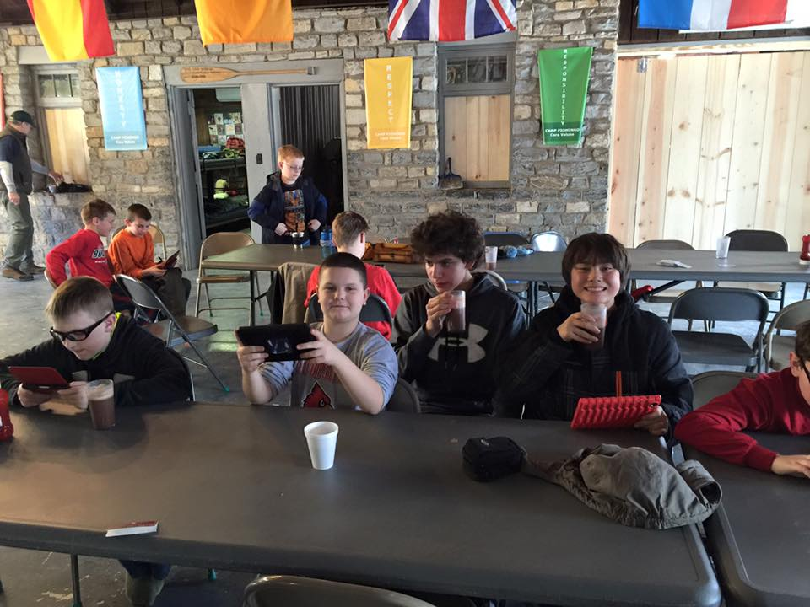
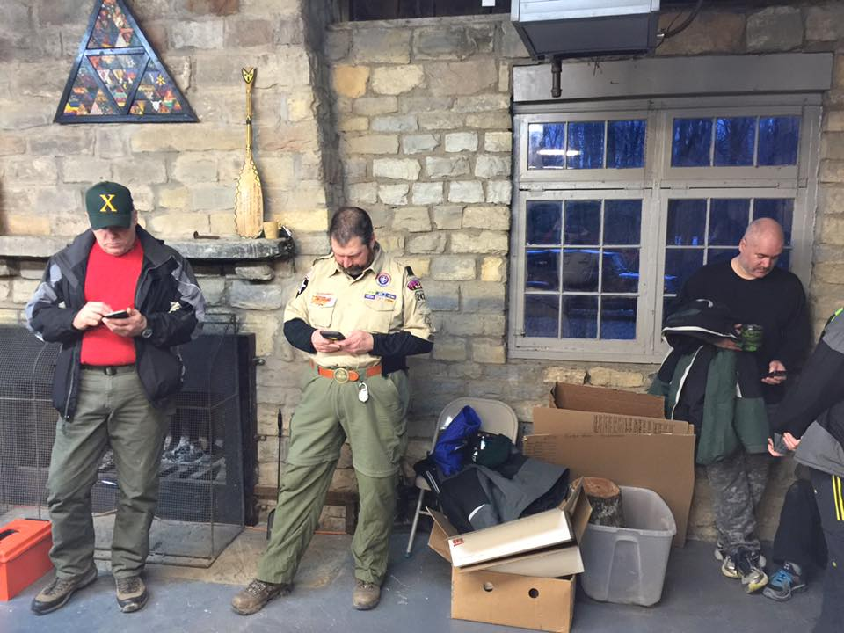

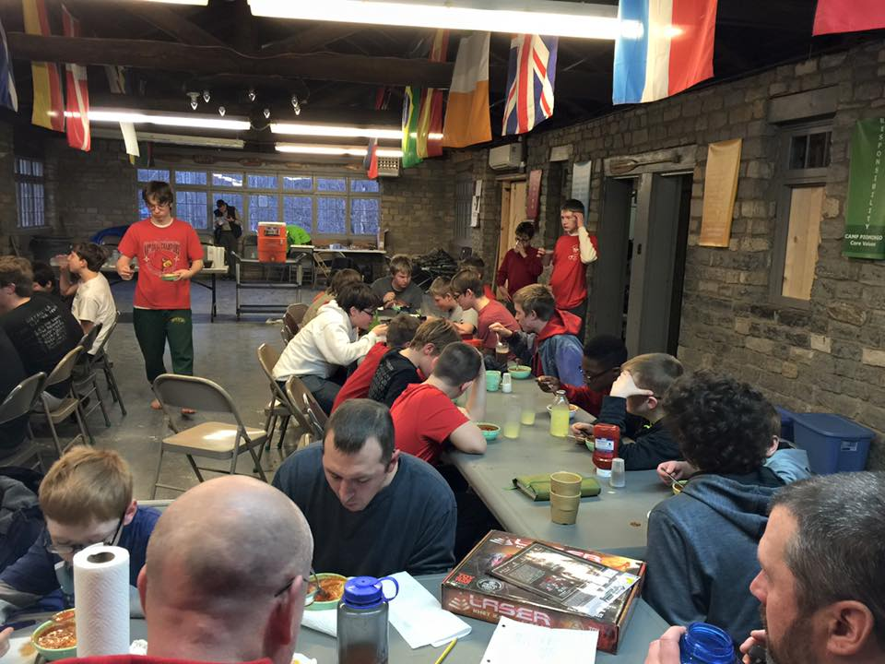

To the left is a shot of the most important thing that happens on this outing, eating well above average food fixed by returning Eagle Scouts from Troop 243. Below is a picture of the entire group. Good times.

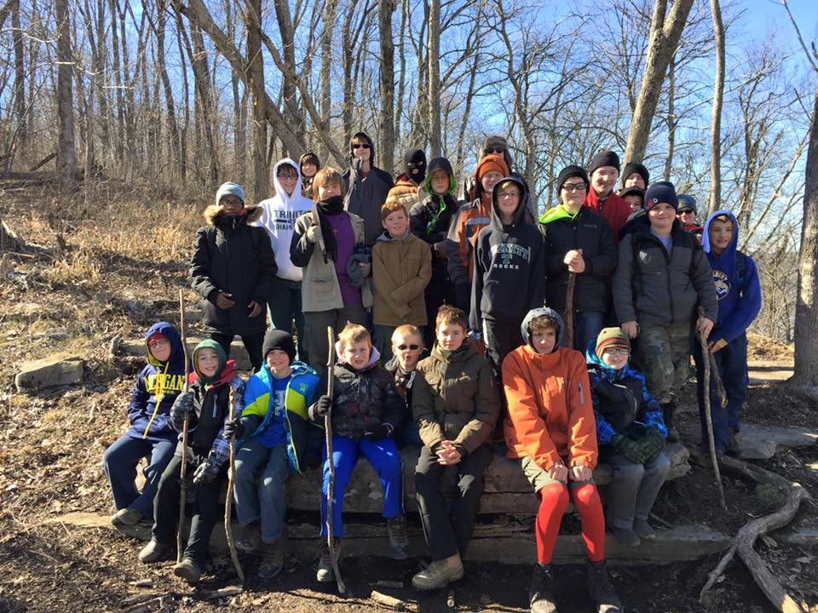

At the end of February we held our Quarterly Court of Honor that was used to install all new Troop Scout Leadership including the Junior Assistant Scout Master position, which will be filled by Nick Craven. Good luck to all of the new leadership. Below is a picture of our new leadership.
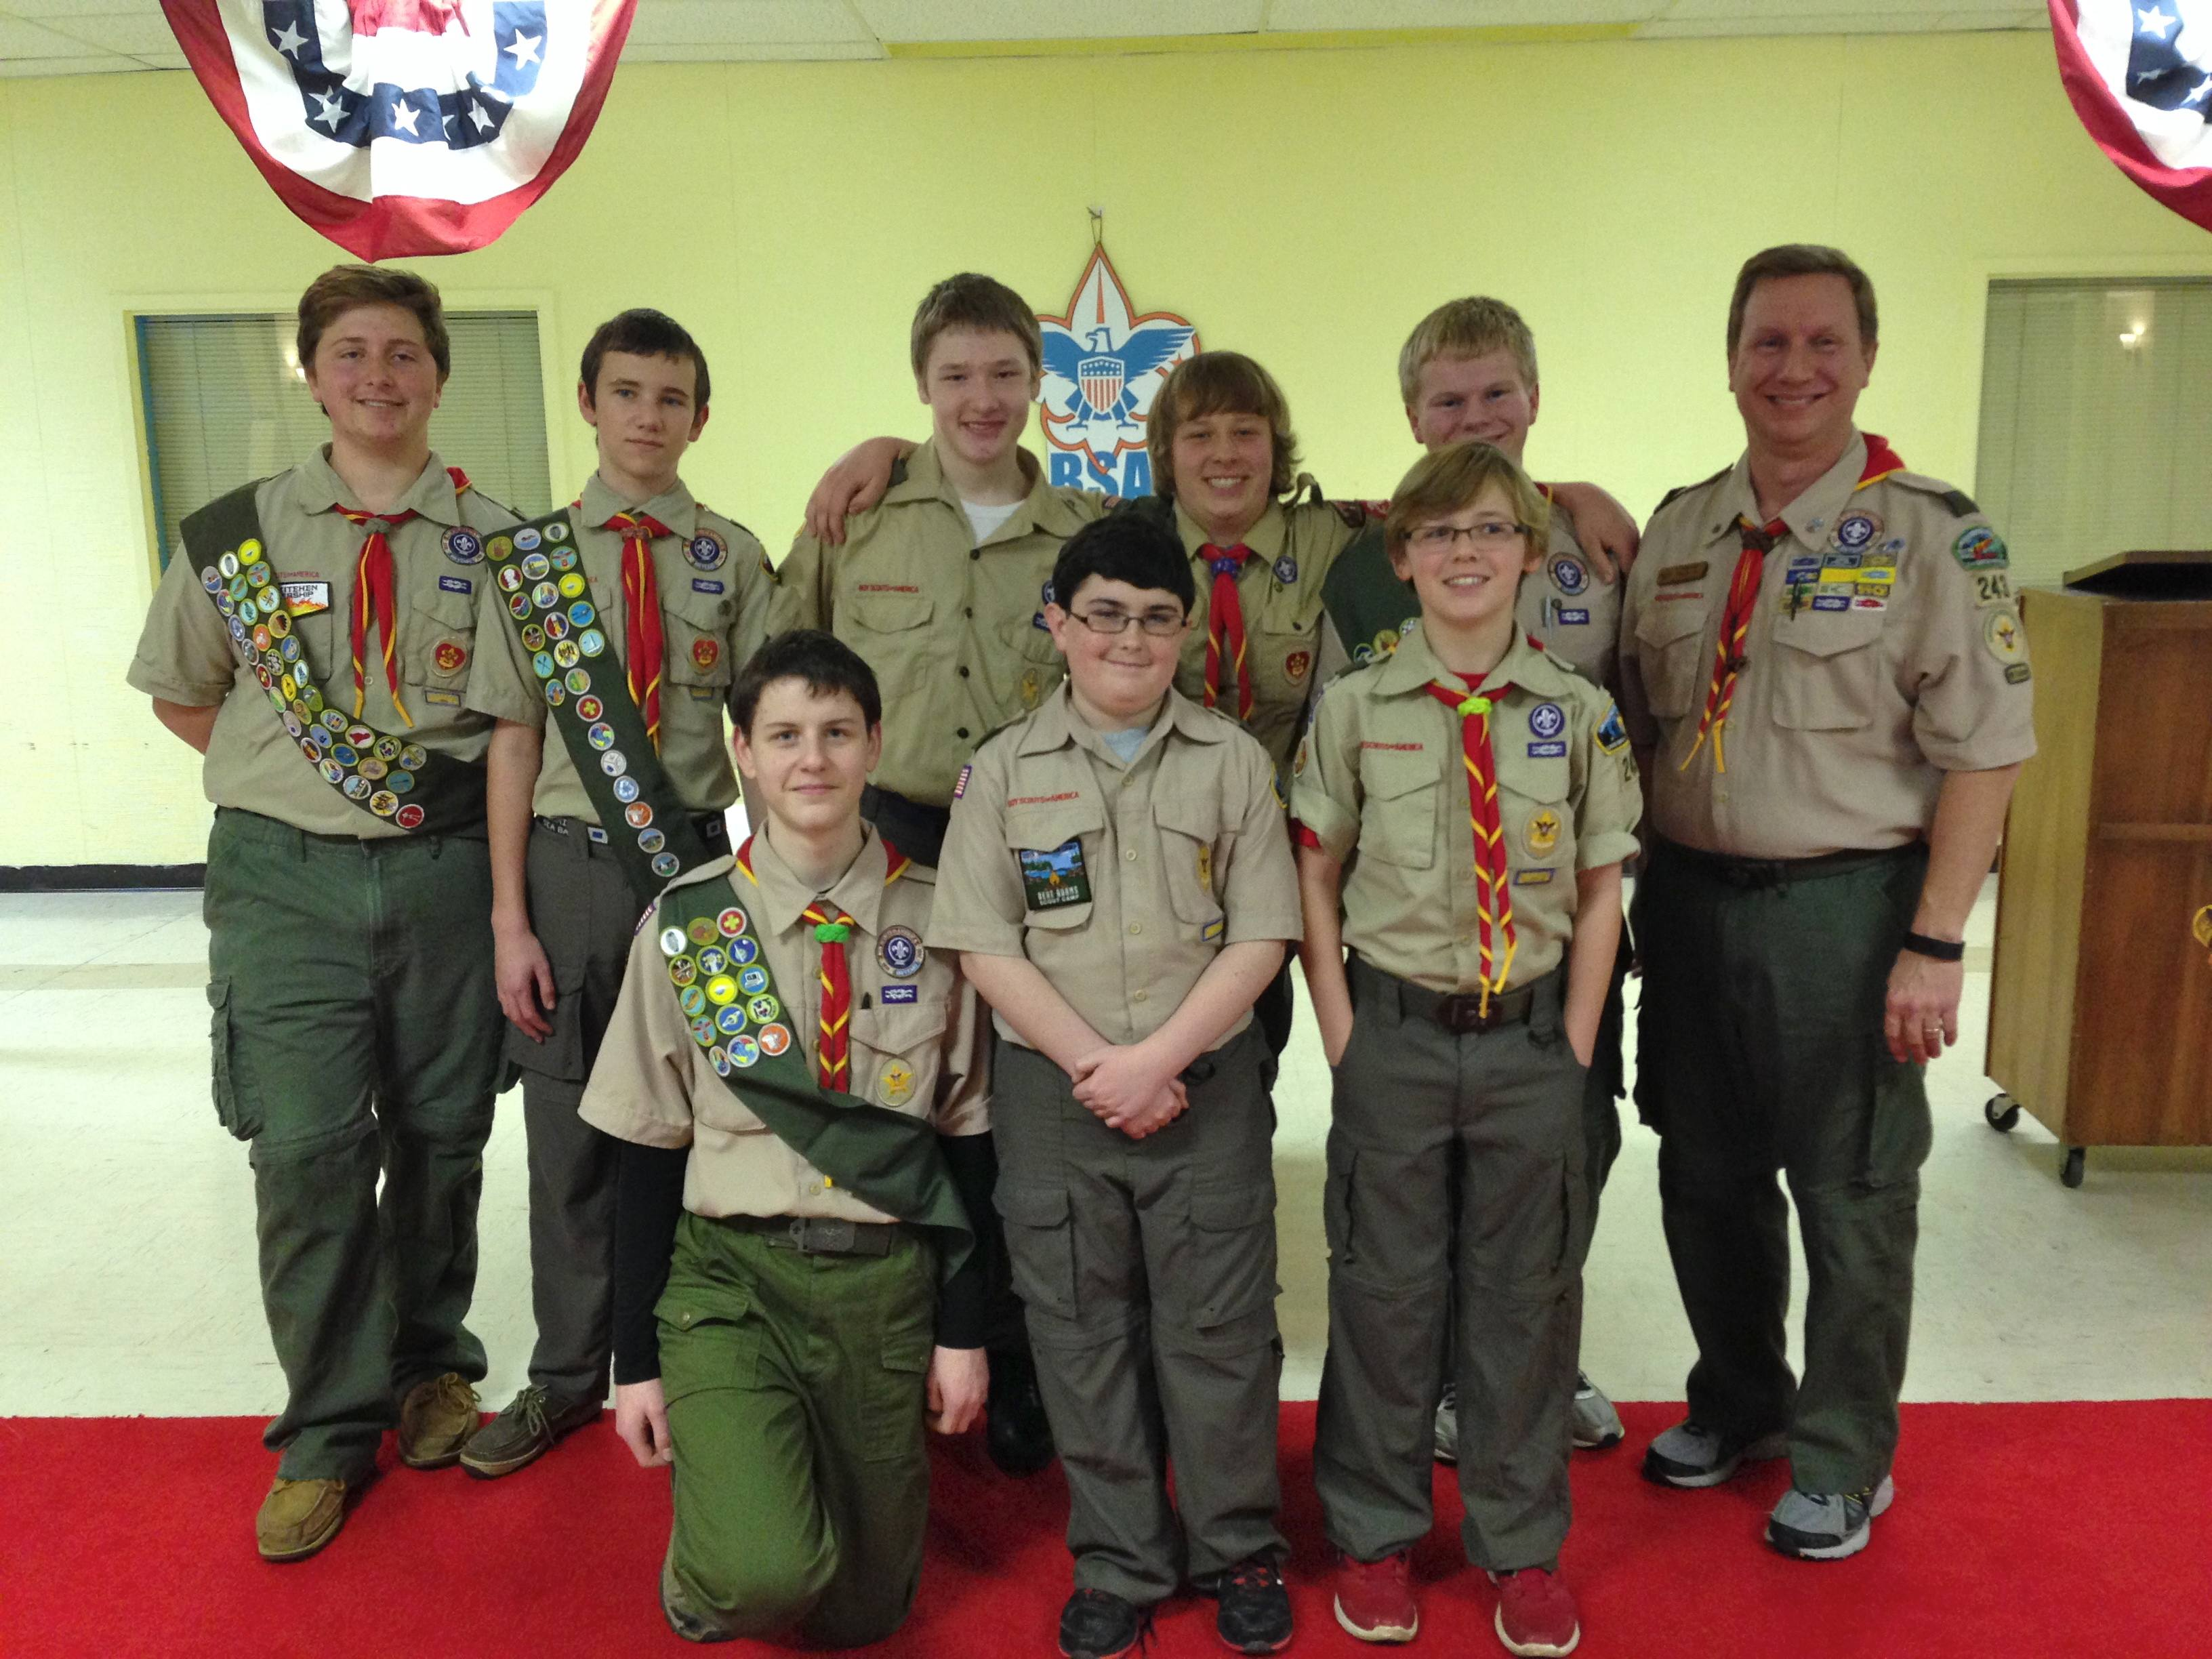
To the right, Tom Doyle represents the entire troop thanking Todd Early for his service as the Scoutmaster for the past 3 years and welcoming Chuck Pemberton as he fills some very large shoes. Thanks to Chuck also!


